Day 14 - 04th Aug 2026

Task 1:
What do you understand about Git collaboration?
9.19 to 9.22

Task 2:
Why is collaboration necessary while working on git?
9.23 to 9.25

Task 3:
What are the commands that we use while collaborating?
9.26 to 9.35

Task 4:
Can you show the typical work flow while working on Git ?
9.36 to 9.40

Task 5:
Give some to do practices that we need to follow while working on Git Repo on a daily basis.
9.41 to 9.45

Install nodejs

https://nodejs.org/en?utm_source=copilot.com

Node -v → verify the node version

Then install
npm install --global typescript

Check for version
Tsc -v
7++ is good (as of now)

npm init -y
npm install express body-parser cors
npm install typescript ts-node nodemon @types/node @types/express --save-dev

rmdir /s /q node_modules
del package-lock.json

Task 6:
Create a demo typescript file and execute it

Task 7:
Create an interface and try it out?

Task 8:
In the above code use optional variable ?

Task 9:
Create a demo with constructor, default and with parameterised..

Task 10;
What are primitive and special data types in typescript?
11.43 to 11.45

Task 11:
Create a class with access modifiers.
11.46 to 11.51

Task 12:
To create a typescript file and run it… what are the steps … that we need to follow.. (lets suppose if I am creating ts file for the first time in my sys).

Task 13:
Create a demo and see how generics work in ts.

Task 14:
What are type annotations in typescript?

Task 15:
What is the purpose of the any keyword in typescript?

Task 16:
Can you give an example to show the difference between any and unknown.

Task 17:
What is the tsconfig.json file used for ?

Task 18:
Code
banking-app/
├── backend/
│ ├── src/
│ │ ├── index.ts
│ │ ├── routes/
│ │ │ └── accountRoutes.ts
│ │ ├── controllers/
│ │ │ └── accountController.ts
│ │ ├── models/
│ │ │ └── account.ts
│ │ └── services/
│ │ └── accountService.ts
└── frontend/
└── Angular project (ng new banking-ui)

1 to 2 lunch break..

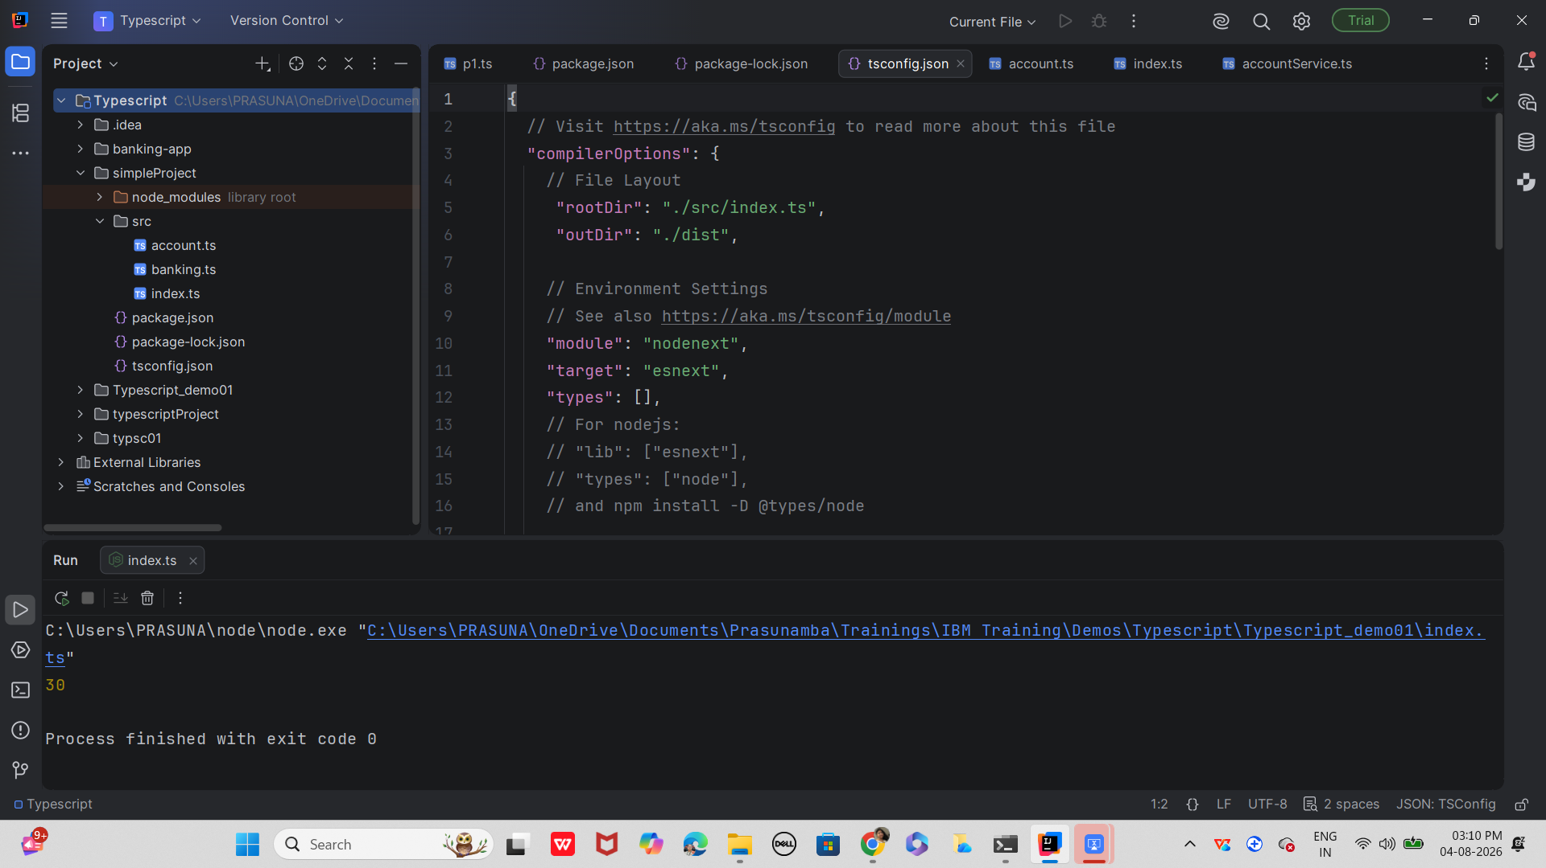

Plz ensure//

models/account.ts
ts
export interface Account {
id: number;
name: string;
balance: number;
}

services/accountService.ts
ts
import { Account } from "../models/account";

let accounts: Account[] = [
{ id: 1, name: "Prasunamba", balance: 5000 },
{ id: 2, name: "Meher", balance: 3000 }
];

export const getAccounts = (): Account[] => accounts;

export const getAccountById = (id: number): Account | undefined =>
accounts.find(acc => acc.id === id);

export const deposit = (id: number, amount: number): Account | undefined => {
const account = getAccountById(id);
if (account) account.balance += amount;
return account;
};

export const withdraw = (id: number, amount: number): Account | undefined => {
const account = getAccountById(id);
if (account && account.balance >= amount) account.balance -= amount;
return account;
};

routes/accountRoutes.ts
ts
import { Router } from "express";
import { getAllAccounts, depositAmount, withdrawAmount } from "../controllers/accountController";

const router = Router();

router.get("/", getAllAccounts);
router.post("/deposit", depositAmount);
router.post("/withdraw", withdrawAmount);

export default router;

controllers/accountController.ts
ts
import { Request, Response } from "express";
import * as accountService from "../services/accountService";

export const getAllAccounts = (req: Request, res: Response) => {
res.json(accountService.getAccounts());
};

export const depositAmount = (req: Request, res: Response) => {
const { id, amount } = req.body;
const account = accountService.deposit(id, amount);
account ? res.json(account) : res.status(404).send("Account not found");
};

export const withdrawAmount = (req: Request, res: Response) => {
const { id, amount } = req.body;
const account = accountService.withdraw(id, amount);
account ? res.json(account) : res.status(400).send("Insufficient funds");
};

index.ts
ts
import express from "express";
import bodyParser from "body-parser";
import cors from "cors";
import accountRoutes from "./routes/accountRoutes";

const app = express();
app.use(cors());
app.use(bodyParser.json());

app.use("/api/accounts", accountRoutes);

const PORT = 5000;
app.listen(PORT, () => {
console.log(`Server running on http://localhost:${PORT}`);
});

tsconfig.js

{
// Visit https://aka.ms/tsconfig to read more about this file
"compilerOptions": {
// File Layout
// "rootDir": "./src",
// "outDir": "./dist",

// Environment Settings
// See also https://aka.ms/tsconfig/module
"module": "nodenext",
"target": "esnext",
"types": [],
// For nodejs:
// "lib": ["esnext"],
// "types": ["node"],
// and npm install -D @types/node

// Other Outputs
"sourceMap": true,
"declaration": true,
"declarationMap": true,

// Stricter Typechecking Options
"noUncheckedIndexedAccess": true,
"exactOptionalPropertyTypes": true,

// Style Options
// "noImplicitReturns": true,
// "noImplicitOverride": true,
// "noUnusedLocals": true,
// "noUnusedParameters": true,
// "noFallthroughCasesInSwitch": true,
// "noPropertyAccessFromIndexSignature": true,

// Recommended Options
"strict": true,
"jsx": "react-jsx",
"verbatimModuleSyntax": true,
"isolatedModules": true,
"noUncheckedSideEffectImports": true,
"moduleDetection": "force",
"skipLibCheck": true,
}
}

Run backend ..

